**Features**

### 1. JSX (JavaScript Syntax Extension)

JSX allows developers to write HTML-like syntax directly within JavaScript code. This blend simplifies the creation of React components by making the code more readable and expressive. Since browsers don't natively understand JSX, tools like Babel transform it into standard JavaScript.

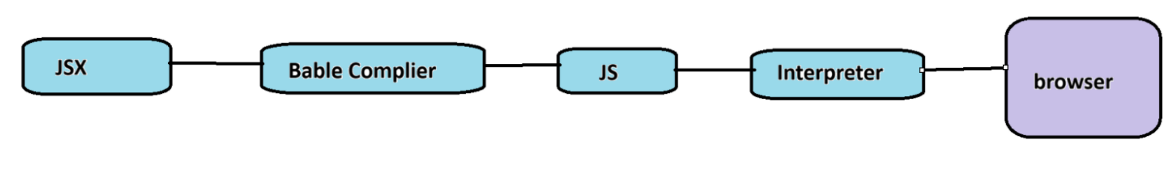 Ways to write jsx:

1.div tag

2.Array

3.Fragment

4.Sugar syntax

**2.One-way Data Binding:**

One-way data binding, the name itself says that it is a one-direction flow. The data in react flows only in one direction i.e. the data is transferred from top to bottom i.e. from parent components to child components.

**3.Components:**

React.js divides the web page into multiple components as it is component-based. Each component is a part of the UI design which has its own logic and design.

**4. Performance:**

React uses virtual DOM and updates only the modified parts. So , this makes the DOM run faster. DOM executes in memory so we can create separate components which makes the DOM run faster.

**5. Virtual DOM:**

* Virtual DOM is a lightweight copy of Real DOM.
* In react because of virtual dom instead of full page reload react made changes on necessary parts of the page.

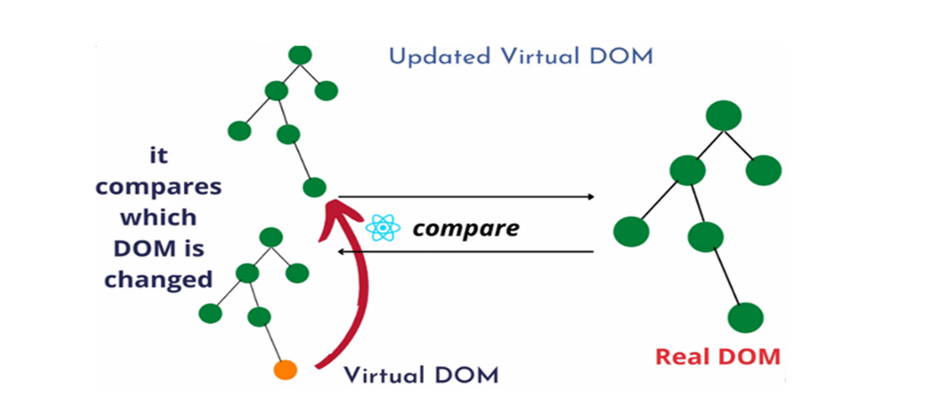

 In Virtual DOM there are two important process -

1. **Diffing Process**

             In React, virtual dom compares with pre-updated virtual and made changes on pre-updated virtual dom this process is called diffing process.

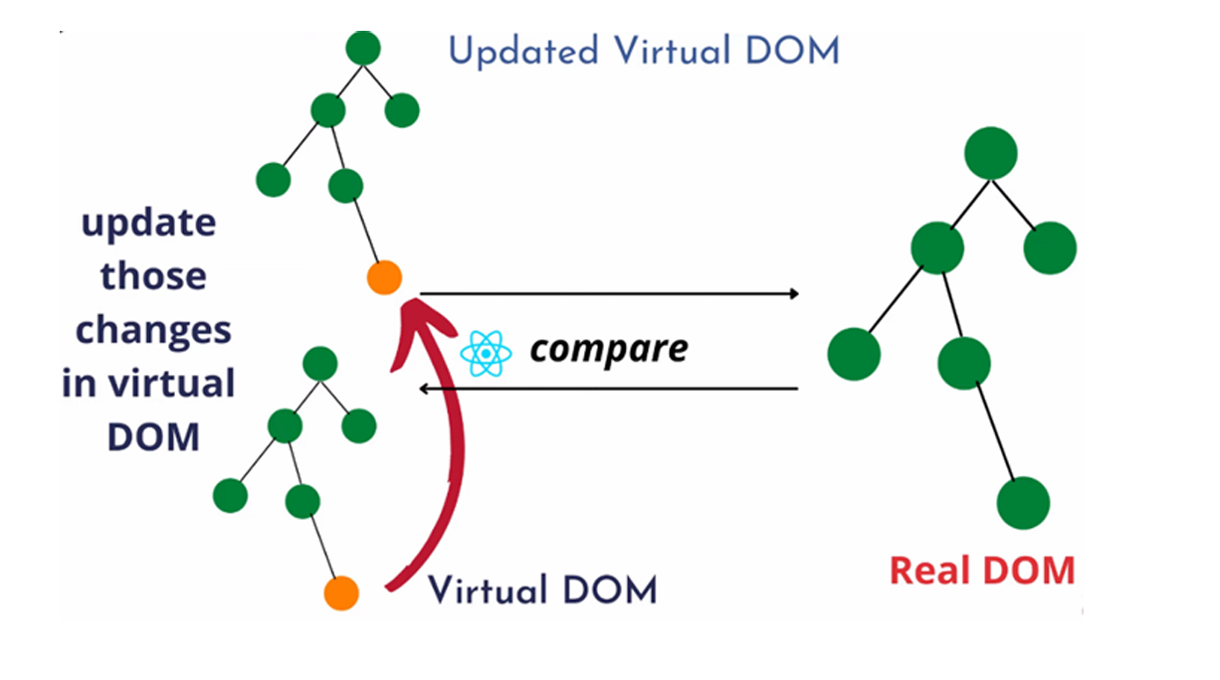

2. **Reconciliation Process**

**Reconciliation** is the process of updating the real DOM to match the new Virtual DOM after the differences have been identified through diffing. React efficiently updates only the parts of the DOM that have changed, rather than re-rendering the entire UI.

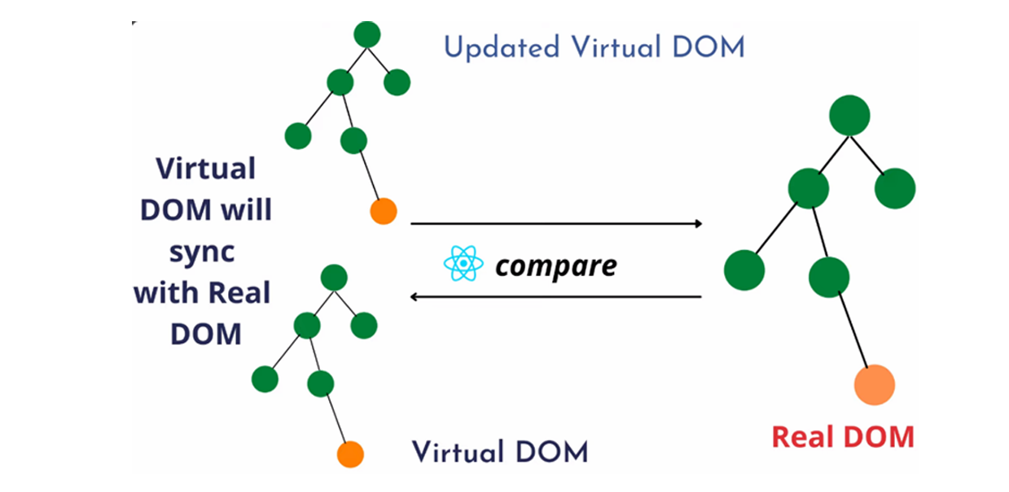

This process involves applying the identified changes to the real DOM in the most efficient way possible. Instead of rebuilding the entire DOM from scratch, React applies the minimal necessary updates to bring the real DOM in sync with the Virtual DOM.

**What is Component ?**

 • A Component is reusable blocks of code which is use to create a UI.

• Components are like functions that return HTML elements.

• Components are independent and reusable bits of code.

• Components are more powerful than function.

There are 2 different type of components:

1.function Base Components

2.Class Base Components

**1.Function Base Components:**

Function components are the simpler and more modern way to define components in React. It is similar to JavaScript functions that return JSX.

**2.Class Base Components**

In class-based components, you need to extend(inherit) React.Component to give your component the necessary functionality.

A class component must contain a render() method, which returns JSX to describe what should be displayed on the screen.

Syntax:

Class class_nm extends Component

**Type of Module Export**

1. Default Export

2. Named Export

**Default Export : -**  A **default export** allows you to export a single value or component from a file. The default export can be imported with any name.

**Named Export :-** A named export allows you to export multiple components or values from a file. Each component or value you export has to be imported with the exact name it was exported with. we can import that object or component with same name in curly braces {}.

You can export multiple named components/values and import them using their exact names.

**There are 3 ways to implement CSS in React –**

o Inline CSS

 <h1 style={{color:"red",backgroundColor:"yellow"}}>

This is my class base component

</h1>

o Style attribute takes CSS properties in Object form { }

class App extends Component{

  obj = {color:"red",backgroundColor:"yellow"}

  render(){

    return(

      <>

      <h1 style={this.obj}>This is my class base component</h1>

      </>

    )

  }

}

o External CSS

import "./style.css"

//class base component

class App extends Component{

  obj = {color:"red",backgroundColor:"yellow"}

  render(){

    return(

      <>

      <h1 >This is my class base component</h1>

      </>

    )

  }

}

Git link:

https://github.com/apurvamrajput/react